Thich Nhat Hanh
(1926-2022)

“It’s not enough just to talk about compassion; we have to do the work of compassion”
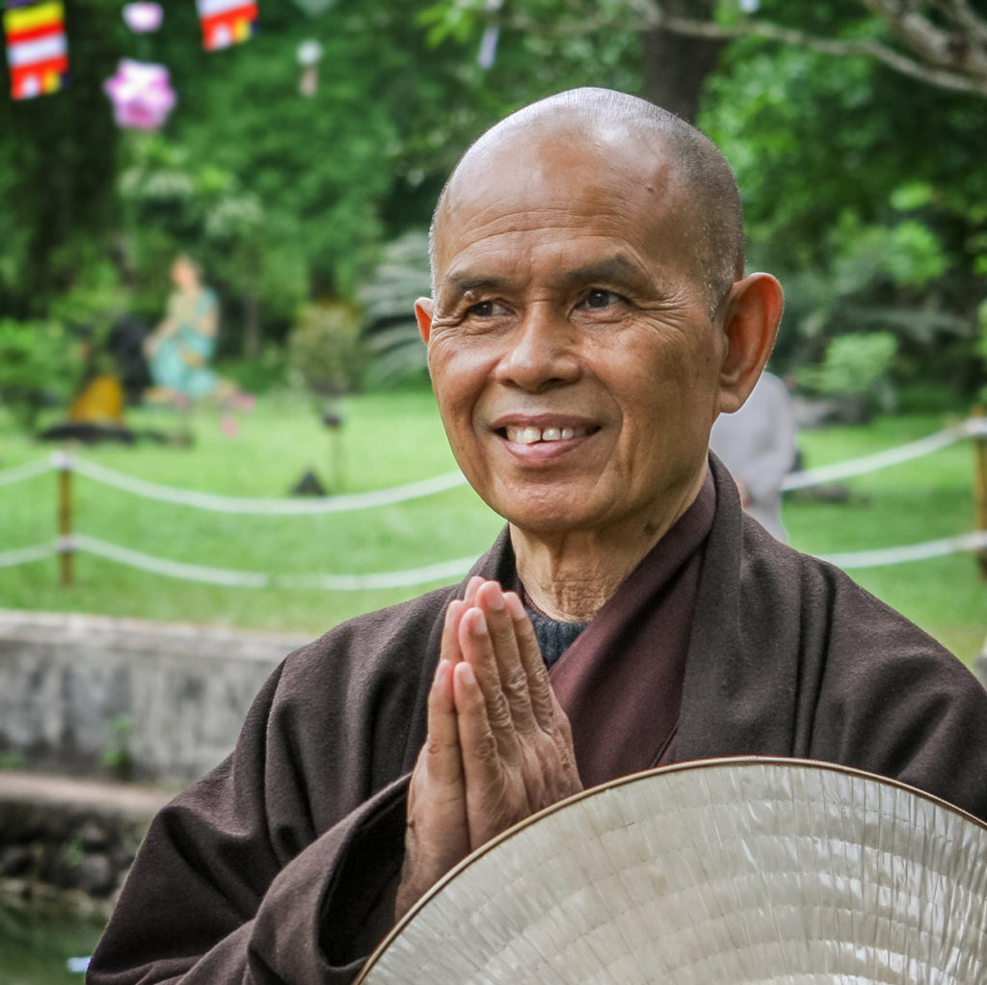

A poet, author, peace activist and global spiritual leader - Thich Nhat Hanh’s teachings have inspired a generation of buddhists, humanitarians and activists alike. Exiled from his home country of Vietnam for 39 years, Nhat Hanh consistently advocated for non-violent solutions to conflict. His books and poetry offer wisdom on topics from grief to the climate crisis, and his legacy of engaged buddhism has helped to share buddhist teachings with a global audience.

In the early 1950s, with Vietnam engaged in an anti-imperial war against France, the Vietnamese Buddhist establishment remained largely apolitical. Nhat Hanh however, felt that buddhism should involve engaging directly with people’s struggles, and through his writings he founded the engaged buddhist movement.

When war again broke out in Vietnam in 1955, Nhat Hanh became an early voice of the antiwar movement. During this time, Nhat Hanh travelled to America, sharing his plea for peace, while his poems were used as protest songs by peace activists in Vietnam. In 1966 he embarked on a tour of US universities and churches, and spoke at a press conference in Washington DC. There, he presented a five-point proposal, calling for peace on both sides and an immediate ceasefire. In response, he was labelled a national traitor by Vietnamese media, and was refused the right to return to Vietnam. This marked the start of a nearly 40-year exile.

During his time in exile, Nhat Hanh continued to speak out against war. In 1967 he published the book Lotus in a Sea of Fire in the US - a hard-hitting plea to end violence - which was also published underground in Vietnam. He was also deeply concerned by the thousands of refugees forced to flee Vietnam by boat in the aftermath of the war. Along with his followers, Nhat Hanh hired boats and ships to search Singaporean waters - ultimately rescuing over 800 people.

After being granted asylum in France, Nhat Hanh went on to establish a mindfulness practice centre in the Dordogne Valley - known as Plum Village. Today, Plum Village is the biggest and most active Buddhist monastery in the West. Over the course of his life, Thich Nhat Hanh published over 100 books, selling tens of millions of copies worldwide. He is widely regarded as one of the most influential buddhist teachers of the last century.

